Activity Sheet Answers
Chapter 4, Lesson 1

Protons, Neutrons, and Electrons

INTRODUCTION

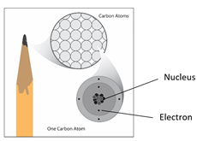
- Label the nucleus (protons, neutrons) and electrons in the drawing of a carbon atom.

- Draw a line between the subatomic particle and its charge.

- Would the following subatomic particles attract each other or repel one another?
Two protons: Repel
Two electrons: Repel
A proton and an electron: Attract

EXPLAIN IT WITH ATOMS & MOLECULES

- Write “Attract” or “Repel” in the chart and describe what happened with the electrons and charges to explain your observations in the last box in the chart.
What happened when you brought the following materials near each other?
Materials | Attract or Repel | Explain
Charged plastic + charged skin | Attract | Plastic is negative and skin is positive so opposites now attract
Charged plastic + neutral desk | Attract | Plastic is negative and desk is neutral but more positive near the plastic so opposites now attract
Charged plastic + charged plastic | Repel | Both pieces of plastic have excess electrons and are negatively charged; like charges repel

TAKE IT FURTHER
- Write captions beneath each picture explaining what happened between the balloon and your hair and the balloon and the paper in the activity.

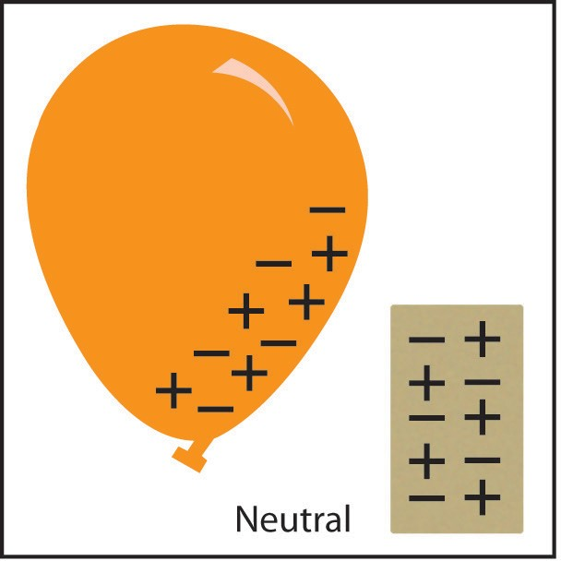
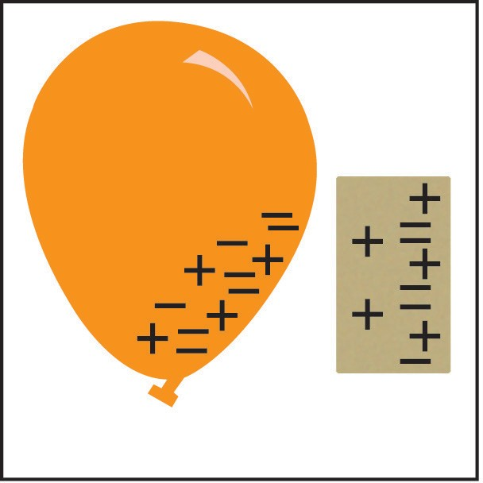
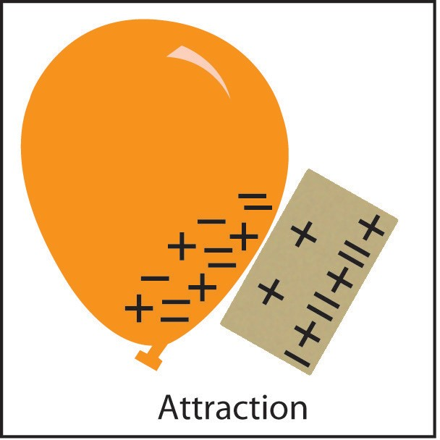
Initially, the paper and balloon are both neutral and not attracted to one another.
After rubbing the balloon against your hair, excess electrons are added to it. When it is brought near the paper, the excess electrons on the balloon repel electrons in the paper towel, leaving an excess of protons (positive charge) near the balloon.
The excess electrons on the balloon are now attracted to the area of positive charge in the paper.

